ALGORITHM VISUALIZER
🔷 1. What exactly you’re building (scope, no confusion)
A desktop application that:
- Lets the user choose an algorithm
- Enter input
- Visualizes each step
- Shows step explanation
- Shows time & space complexity
- Runs deterministically (same input → same steps)
This is NOT web dev.
This sits in Software Engineering + Algorithms + Visualization domain.

🔷 2. High-level architecture (big picture)
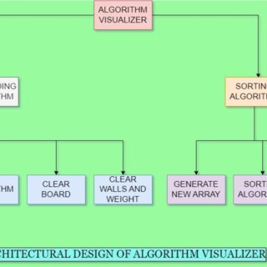
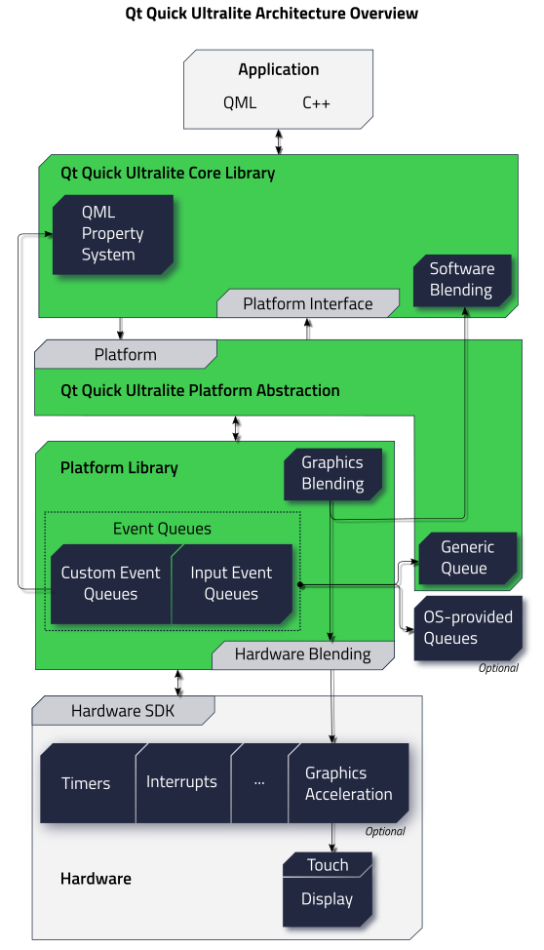
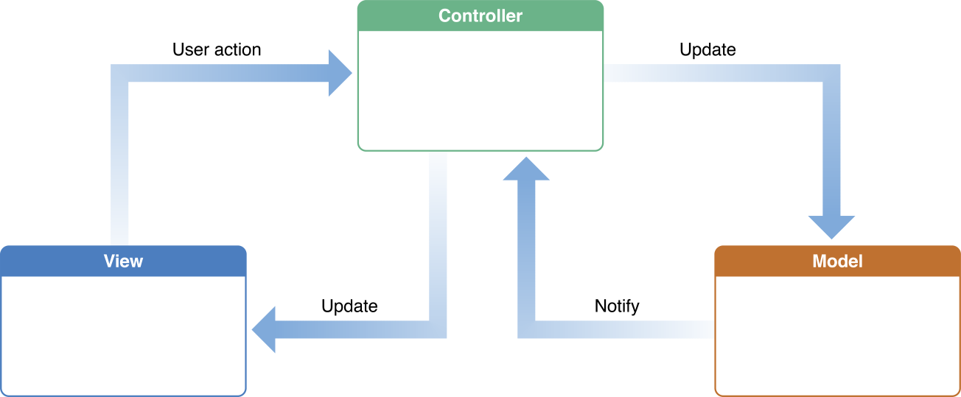
Core layers
UI Layer (Qt Widgets / QML)
↓
Controller (Signal–Slot logic)
↓
Algorithm Engine (C++ / Python)
↓
Visualization Engine
↓
Explanation + Complexity Engine
Keep these separate, or the project will become a mess.

🔷 3. Folder & file structure (clean & scalable)
AlgoVisualizer/
│
├── main.cpp
├── CMakeLists.txt
│
├── ui/
│ ├── MainWindow.ui
│ ├── ControlPanel.ui
│ ├── Canvas.ui
│
├── controllers/
│ ├── MainController.cpp
│ ├── AlgoController.cpp
│
├── algorithms/
│ ├── sorting/
│ │ ├── bubble.cpp
│ │ ├── selection.cpp
│ │ ├── merge.cpp
│ │ └── quick.cpp
│ ├── searching/
│ │ ├── binary.cpp
│ │ └── linear.cpp
│ └── graph/
│ ├── bfs.cpp
│ ├── dfs.cpp
│ └── dijkstra.cpp
│
├── visualizer/
│ ├── ArrayVisualizer.cpp
│ ├── GraphVisualizer.cpp
│ └── StepRecorder.cpp
│
├── explanation/
│ ├── bubble.txt
│ ├── merge.txt
│ └── dijkstra.txt
│
├── complexity/
│ └── complexity_map.json
│
└── assets/
├── icons/
└── themes/
📌 Rule:
Algorithm code never touches UI directly.

🔷 4. Algorithm execution model (MOST IMPORTANT)
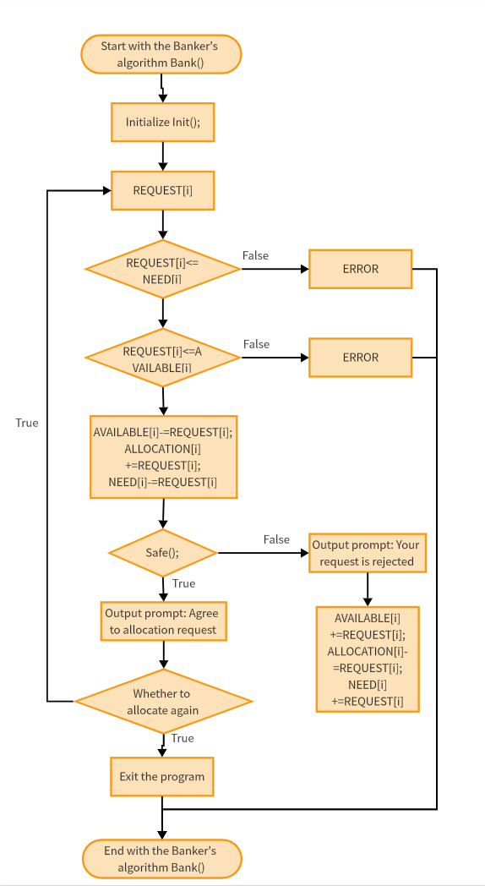
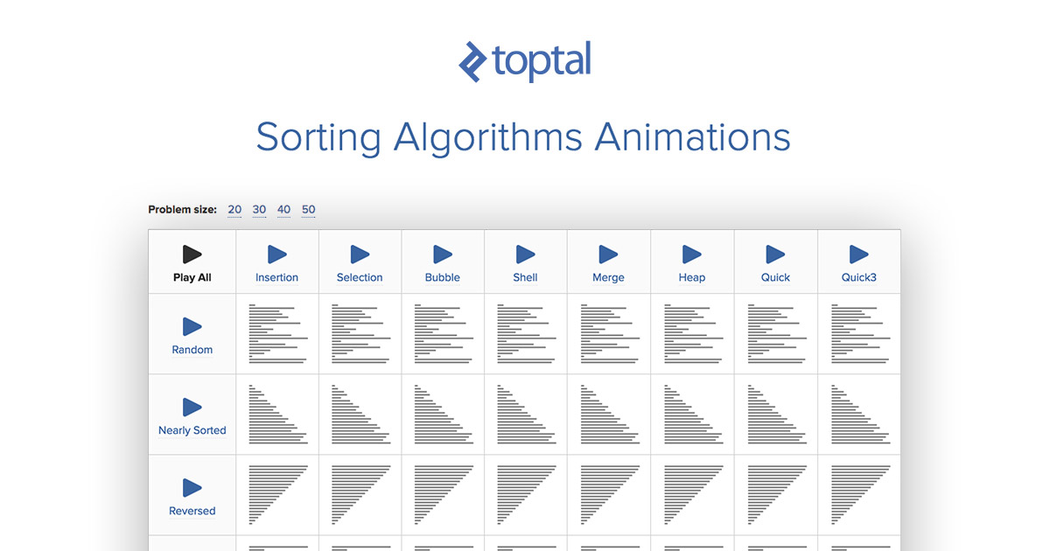
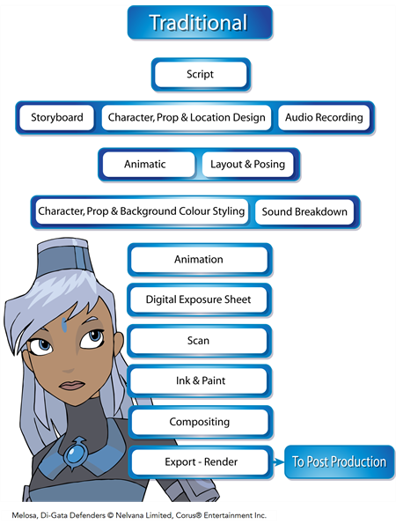
You do NOT animate inside the algorithm.
Instead:
Step 1: Algorithm records steps
struct Step {
vector<int> state;
int i, j;
string action;
};
Algorithm pushes steps:
steps.push_back({arr, i, j, "Swapping elements"});
Step 2: Visualizer consumes steps
- Timer (QTimer)
- Each tick → render next step
- UI never blocks
This is industry-correct design.

🔷 5. Visualization strategy (simple but effective)
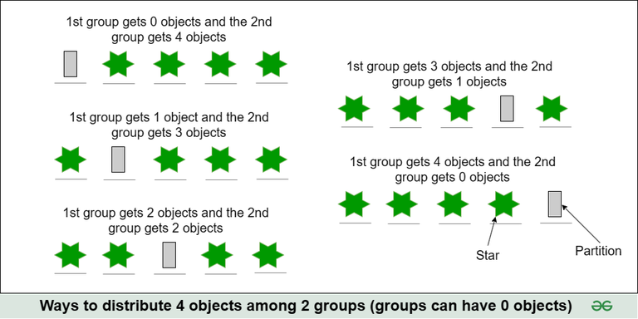
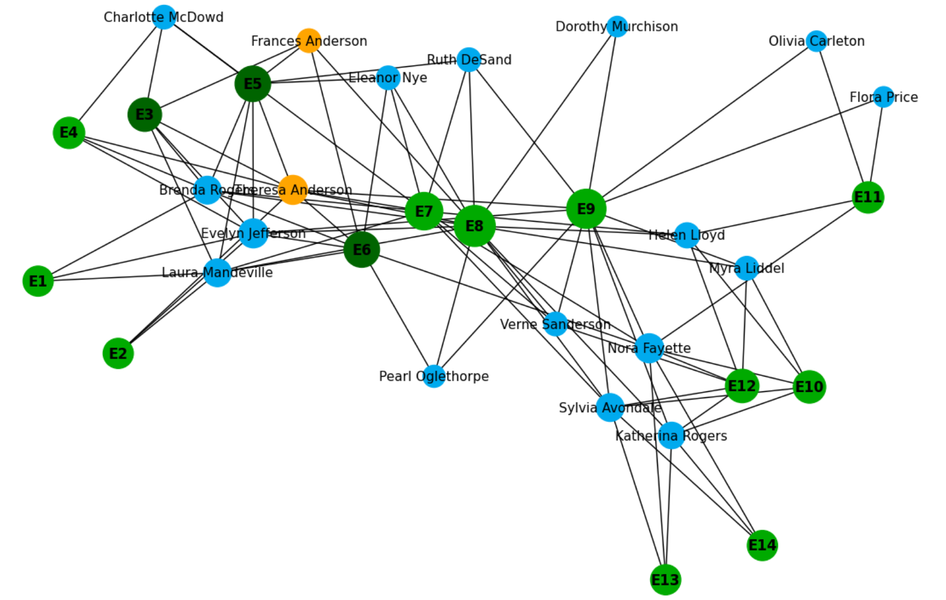
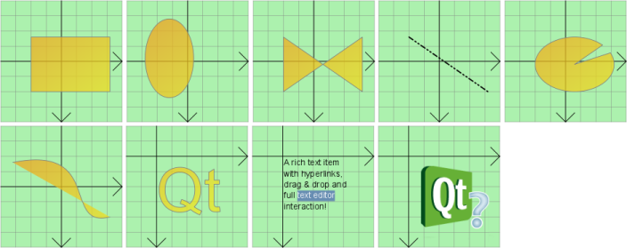
For arrays
- Vertical bars
- Color coding:
  - 🔴 being compared
  - 🟢 sorted
  - 🔵 current pointer
For graphs
- Nodes as circles
- BFS/DFS queue/stack visible
- Dijkstra: edge weights highlighted
Use:
- QGraphicsView
- QGraphicsScene
Avoid fancy animations early. Clarity > beauty.

🔷 6. Explanation engine (theory + logic)
Each algorithm has:
- Plain-English explanation file
- Loaded dynamically
Example:
Step 4:
We compare arr[2] and arr[3].
Since arr[2] > arr[3], we swap them.
This directly helps:
- University viva
- GATE understanding
- Resume walkthroughs

🔷 7. Complexity module (static, no overengineering)
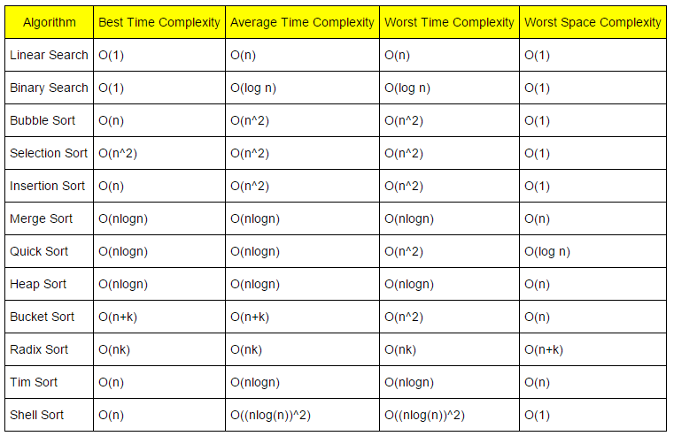

Store once:
{
"bubble_sort": {
"best": "O(n)",
"avg": "O(n^2)",
"worst": "O(n^2)",
"space": "O(1)"
}
}
Display when:
- Algorithm finishes
- Or user clicks “Show Complexity”

🔷 8. Team task distribution (as a leader)
YOU (Leader)
- Overall architecture
- QT UI + controllers
- Easy algorithms (bubble, selection, linear search)
- GitHub repo management
Member 2 (Python-friendly)
- Hard algorithms:
  - Merge Sort
  - Quick Sort
  - Dijkstra
- Logic + step recording
- You integrate into C++ later (or via JSON)
Member 3 (Animator)
- ArrayVisualizer
- GraphVisualizer
- Colors, transitions, clarity
Member 4 (Content)
- Algorithm explanations
- Complexity tables
- README + report
If someone can’t deliver code → they deliver value elsewhere.

🔷 9. Git & workflow (non-negotiable)
- Everyone codes locally
- Push via GitHub
- Branches:
  - ui
  - algorithms
  - visualizer
- Only you merge to main
No Google Drive nonsense.

🔷 10. Minimum algorithm list (don’t overdo)
Sorting
- Bubble
- Selection
- Merge
- Quick
Searching
- Linear
- Binary
Graph
- BFS
- DFS
- Dijkstra
This is enough to impress if done cleanly.

🔷 11. What makes this project STRONG
- Clean separation of logic & UI
- Step-based visualization
- Theory + implementation together
- QT (rare, stands out)
- Shows algorithmic thinking, not copy-paste

